**Chapter 3**

**Vector-Valued Functions**

**3.2 Calculus of Vector-Valued Functions**

**Section Exercises**

**Compute the derivatives of the vector-valued functions.**

1. 

Answer: 

1. 

Answer: 

1.  A sketch of the graph is shown here. Notice the varying periodic nature of the graph.

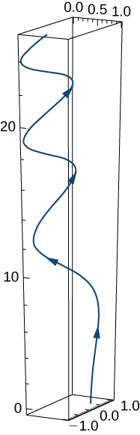

Answer: 

1. 

Answer: 

1. 

Answer: 

1. 

Answer: 

1. 

Answer: 

1. 

Answer: 

1. 

Answer: 

1. 

Answer: 

**For the following problems, find a tangent vector at the indicated value of *t*.**

1. 

Answer: 

1. 

Answer: 

1.  ;

Answer: 

1. 

Answer: 

**Find the unit tangent vector for the following parameterized curves.**

1.  

Answer: 

1.   Two views of this curve are presented here:

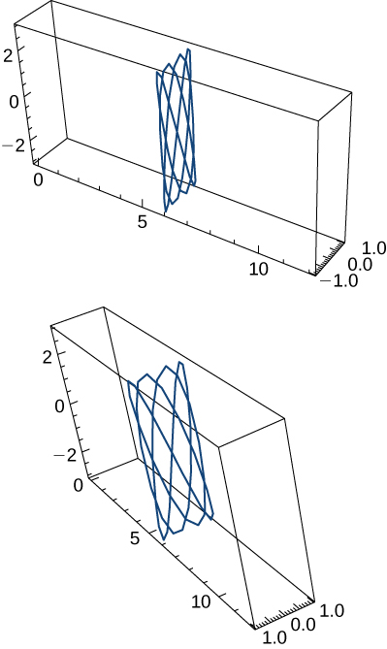

Answer: 

1. 

Answer: 

1. 

Answer: 

**Let  and  Here is the graph of the function:**

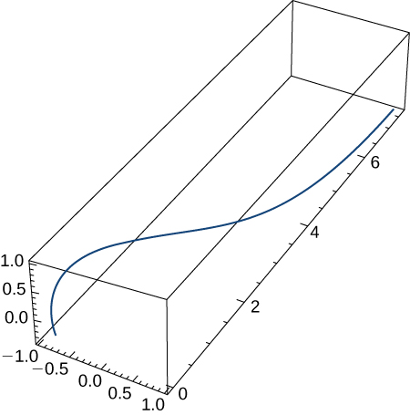

**Find the following.**

1. 

Answer: 

1. 

Answer: 

1. 

Answer: 

1. Compute the first, second, and third derivatives of 

Answer: 

1. Find 

Answer: 

1. The acceleration function, initial velocity, and initial position of a particle are



Find 

Answer:  

1. The position vector of a particle is 
2. Graph the position function and display a view of the graph that illustrates the asymptotic behavior of the function.
3. Find the velocity as *t* approaches but is not equal to  (if it exists).

Answer: a.

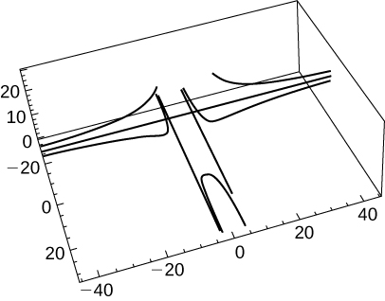

b. Undefined or infinite

1. Find the velocity and the speed of a particle with the position function  The speed of a particle is the magnitude of the velocity and is represented by 

Answer:  speed = 

**A particle moves on a circular path of radius *b* according to the function  where  is the angular velocity, **

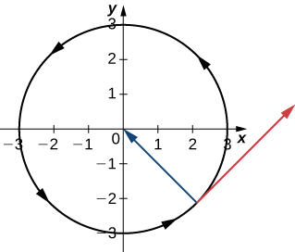

1. Find the velocity function and show that  is always orthogonal to 

Answer:  To show orthogonality, note that 

1. Show that the speed of the particle is proportional to the angular velocity.

Answer:  which implies that speed is directly proportional the angular velocity 

1. Evaluate  given 

Answer: 

1. Find the antiderivative of  that satisfies the initial condition 

Answer: 

1. Evaluate 

Answer: 

1. An object starts from rest at point  and moves with an acceleration of  where  is measured in feet per second per second. Find the location of the object after  sec.

Answer:  feet

1. Show that if the speed of a particle traveling along a curve represented by a vector-valued function is constant, then the velocity function is always perpendicular to the acceleration function.

Answer: 

**The last statement implies that the velocity and acceleration are perpendicular or orthogonal.**

1. Given  and  find 

Answer: 

1. Given  find the velocity and the speed at any time.

Answer:  speed = 

1. Find the velocity vector for the function 

Answer: 

1. Find the equation of the tangent line to the curve  at 

Answer: 

1. Describe and sketch the curve represented by the vector-valued function 

Answer:  a parabola,

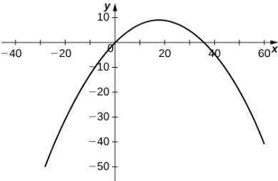

1. Locate the highest point on the curve  and give the value of the function at this point.

Answer:  at 

**The position vector for a particle is  The graph is shown here:**

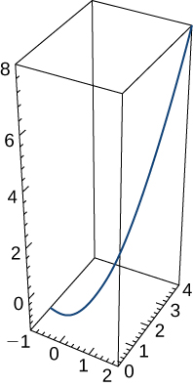

1. Find the velocity vector at any time.

Answer: 

1. Find the speed of the particle at time  sec.

Answer: 

1. Find the acceleration at time  sec.

Answer: 

**A particle travels along the path of a helix with the equation  See the graph presented here:**

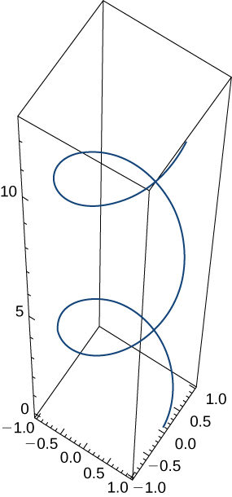

**Find the following:**

1. Velocity of the particle at any time

Answer: 

1. Speed of the particle at any time

Answer: 

1. Acceleration of the particle at any time

Answer: 

1. Find the unit tangent vector for the helix.

Answer: 

**A particle travels along the path of an ellipse with the equation  Find the following:**

1. Velocity of the particle

Answer: 

1. Speed of the particle at 

Answer: 

1. Acceleration of the particle at 

Answer: 

**Given the vector-valued function  (graph is shown here), find the following:**

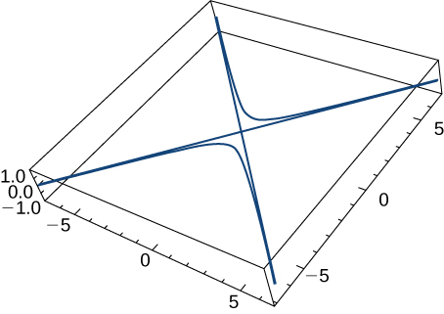

1. Velocity

Answer: 

1. Speed

Answer: 

1. Acceleration

Answer: 

1. Find the minimum speed of a particle traveling along the curve 

Answer: 2

**Given  and  find the following:**

1. 

Answer: 

1. 

Answer: 

1. Now, use the product rule for the derivative of the cross product of two vectors and show this result is the same as the answer for the preceding problem.

Answer: This is a proof; therefore, no answer is provided.

**Find the unit tangent vector T(t) for the following vector-valued functions.**

1.  The graph is shown here:

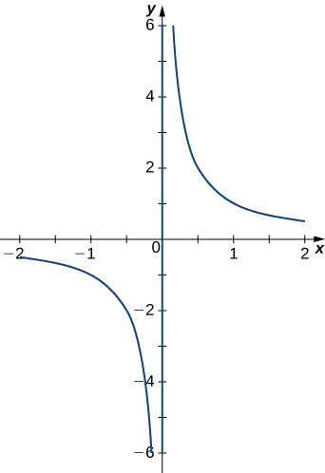

Answer: 

1. 

Answer: 

1. 

Answer: 

**Evaluate the following integrals:**

1. 

Answer: 

1.  where 

Answer: 

This file is copyright 2016, Rice University. All Rights Reserved.